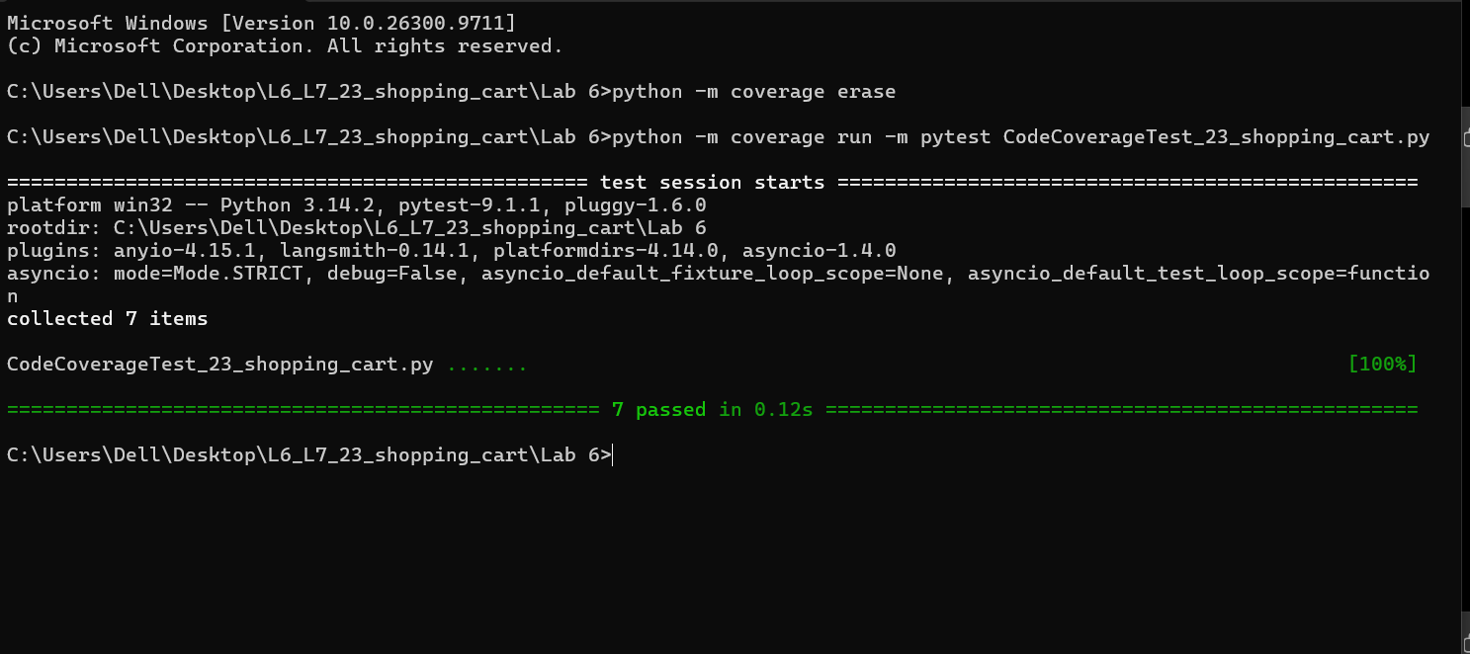
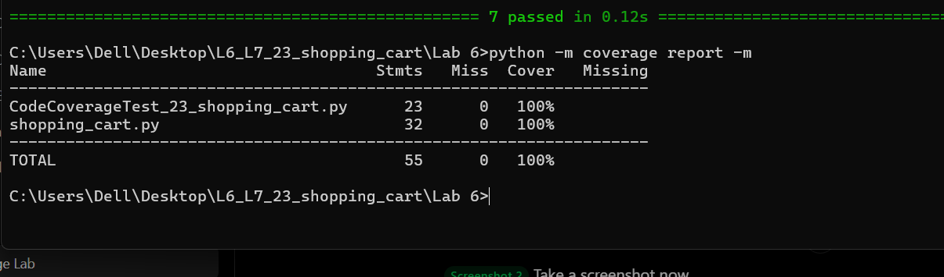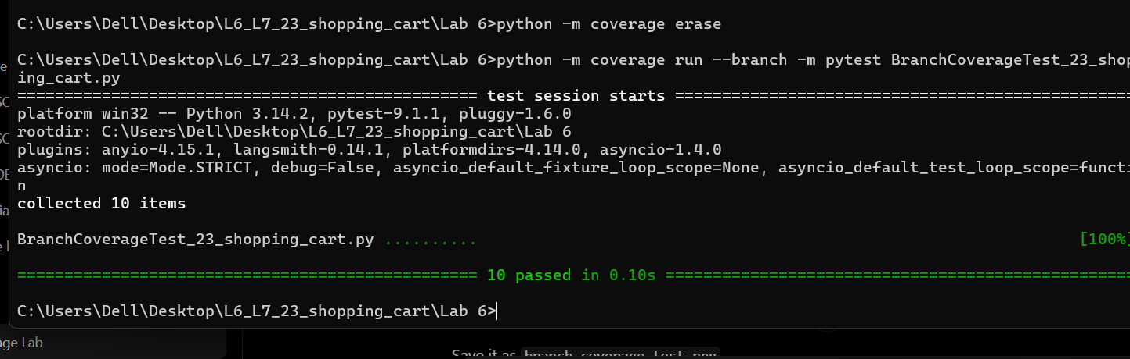
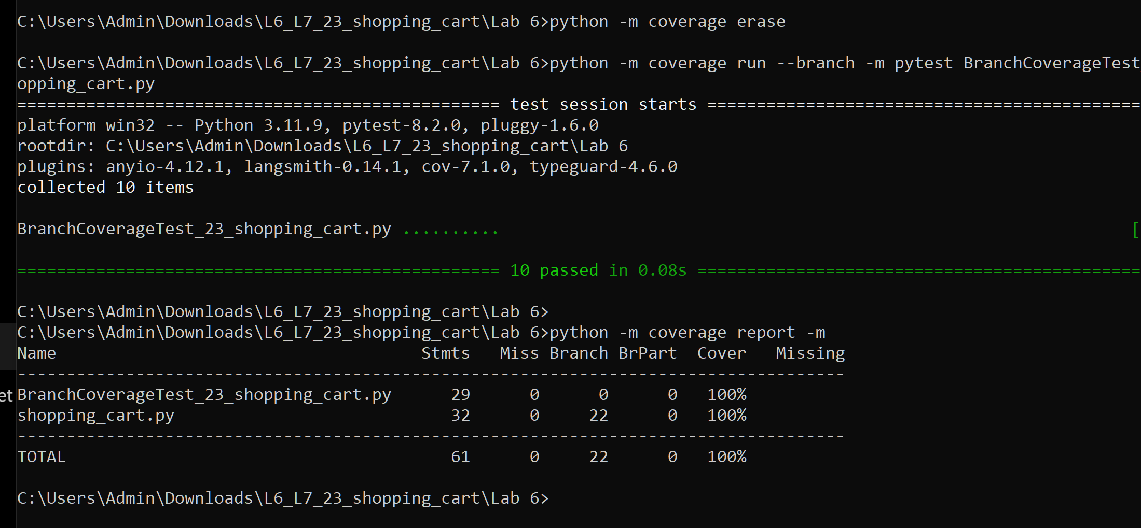https://github.com/Roshan2607/L6_L7_23_shopping_cart

